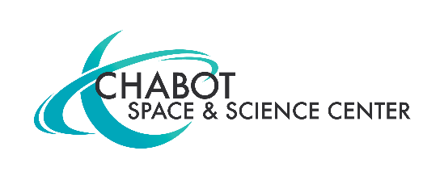
MEDIA CONTACT:
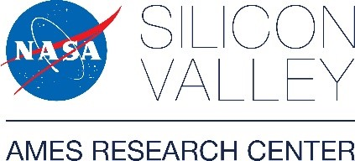
Mary Catherine Frantz
510-336-7338
pr@chabotspace.org
FOR IMMEDIATE RELEASE
CHABOT SPACE & SCIENCE CENTER, IN PARTNERSHIP WITH NASA'S AMES RESEARCH CENTER, PRESENTS NEW EXHIBITION, LUMINOUS MOON, JUNE 22 – SEPTEMBER 8, 2019.

EXHIBITION FEATURES LUNAR ARTIFACTS AND LARGE FORMAT, HIGH RESOLUTION LUNAR IMAGES CAPTURED BY OAKLAND’S OWN CHABOT TELESCOPES, NASA ASTRONAUTS AND NASA’S LUNAR RECONAISSANCE ORBITER.
Oakland, CA, May 22, 2019 – Chabot Space and Science Center partners with NASA's Ames Research Center to create stunning new exhibition exploring the Moon from many unique perspectives.

Opening June 22, Luminous Moon will run through September 8, 2019.

Featuring more than 50 stunning high-resolution images, lunar artifacts and interactive opportunities for all ages, this exhibition invites the public to consider the Moon in new ways.

As part of a growing partnership between Chabot Space and Science Center and NASA Ames, the collaborative effort is developed through consultation with NASA Ames and highlighted by artifacts contributed from the organization.

Located in the Chabot Space and Science Center’s Gruener Astronomy Hall, the photographic essay will transport visitors through revolutionary angles of the Moon that create profound new discoveries and pave the way for future space exploration.

Sweeping images dive into the Moon’s vast landscape through the lens of Oakland’s own astronomers using Chabot’s telescope and from space, taken by NASA astronauts and NASA’s Lunar Reconnaissance Orbiter. These incredible views tell a captivating story about Earth’s nearest neighbor.

“What is fascinating about the Moon is that something so seemingly familiar to us provides exciting new scientific insights and opportunities for exploration, while continually surprising, amazing and delighting us with its extraordinary beauty,” said Chabot’s Executive Director, Adam Tobin.

Detailed pictures are provided by missions from the Lunar Reconnaissance Orbiter (LRO), a satellite launched in 2009 to explore the lunar landscape. NASA’s Gravity Recovery and Interior Laboratory and LRO’s Lunar Orbiter Laser Altimeter provide illustrations of research conducted on the Moon.

The exhibition will also feature six engaging, hands-on interactive activities: Build a lunar habitat using a variety of fun structural materials. Touch the Moon through a three-dimensional landscape filled with ridges and craters. Launch meteorites and create craters. There will be a facilitated workshop area featuring new Moon-related activities every day.

During the exhibition, Chabot will train at least one of its large telescopes on the Moon, as determined by viewing conditions. The Observatory Deck is adjacent to the exhibit gallery. Finally, a Community Talk back Station will enable visitors to join the conversation about the Earth’s closest cosmic neighbor. The station will be a place where guests can share thoughts and read others’ perspectives through a collective reflection on the Moon.

Complementing the exhibition, Chabot will be offering a full summer’s worth of lunar-related events and activities, including events surrounding the 50th Anniversary of the Apollo 11 Moon landing. More information can be found at chabotspace.org.

About Chabot Space & Science Center

Chabot Space & Science Center is a non-profit institution and community resource located on 13 trail-laced acres in Redwood Regional Park in Oakland amid the largest stand of coastal redwoods in the East Bay. Chabot features a 241-seat full dome planetarium, interactive and hands-on exhibits, space artifacts, a giant screen theater, a Challenger Learning Center, and the only research-level telescopes regularly available to the public for weekly live viewing in the Western United States.

Chabot’s mission is to inspire and educate learners of all ages about the Universe and Planet Earth.

Chabot Space & Science Center is open Wed.-Sun. 10 am-5 pm with First Fridays the first Friday of every month 5-9 pm. Admission is Adults: $18 • children 3-12 $14 (under 3 free) • Students/Seniors $15 • Memberships available.

About NASA Ames Research Center

Ames Research Center applies the spirit of Silicon Valley to NASA’s mission, and there's a little bit of Ames in every launch and flight. The center's numerous one-of-a-kind facilities and deep interwoven areas of expertise are vital elements of the nation’s strategy for exploration. Ames combines biology and space technology with two driving aims: detecting life off of our planet, and understanding how Earth life is different in space, so healthy humans can explore from the Moon to Mars. The center leads the national research initiative to devise the best ways for commercial drones, flying cars and today’s aircraft to safely share America’s skies. NASA in Silicon Valley contributes to the nation’s technical prowess as only a government research organization can; when its research matures to a place where others can do it, they seek out partners, invite them in, give them knowledge… and move on to the next unknown.

###

