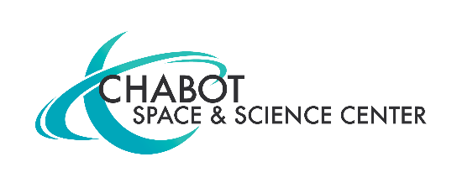
MEDIA CONTACT:
Mary Catherine Frantz
510-336-7338
pr@chabotspace.org
CHABOT SPACE & SCIENCE CENTER HOSTS FIRST ANNUAL BUBBLEFEST AUGUST 17, 10 A.M - 5 P.M.
BUBBLEFEST FEATURES BUBBLE SHOWS FROM RENOWNED ARTISTS, LIVE MUSIC, DIY BUBBLE WAND MAKING AND MORE BUBBLE ACTIVITIES FOR ALL AGES.
Oakland, CA, Aug. 6, 2019 – Chabot’s first-ever BubbleFest brings the science of bubbles to life with an entire day of live shows, music and hands-on activities.
There are activities for all ages at BubbleFest, featuring celebrated bubble artists, live music and multiple hands-on activities. Artists Sterling Johnson and Tom Noddy will be performing astounding live bubble shows. Local band Fleeting Trance will be performing live on the Chabot Observation Deck from 11 a.m. -12 p.m. and 1 p.m. – 3 p.m.
Johnson has performed versions of his remarkable hand-blown bubbles for over 45 years. He is the only person to ever put a bubble inside a bubble inside a bubble on stage without any tubes or straws, and the first person to walk completely through a bubble film. Johnson will be performing 11:30 a.m. Johnson will also be creating giant bubbles at 10-11 a.m. and 3-4 p.m.
Noddy’s work has been featured on the Tonight Show three times. In his 20-plus-year career as America’s Bubble Guy, Tom Noddy has appeared on numerous prime time television shows as well as night clubs and universities. Noddy will be performing at 2 p.m.
There are a variety of hands-on activities. Join Chabot’s resident makers from Project Create to build and test bubble wands made from found objects. Children ages 5 and under will enjoy playing with giant Lego bubbles, rainbow bubbles and other fun bubble creations. Design one of a kind clothing made from bubble wrap at our Tinker Tailor Station. Chabot’s bubblologists will be leading an experimenting station using all sorts of common household items to make strange and wonderful bubbles.
Bubblemania will be bringing bubble wands that look like flowers, butterflies, dinosaurs, dolphins and more, bubbles hoops that make giant bubbles, and bubble racquets and baskets that let bunches of bubbles swirl and fly around. The visual presentation is filled with soap bubble creations that mesmerize the audience with seemingly impossible creations of shimmering, wiggling reflections of light, color and flowing liquid motion, of all shapes and sizes.
BubbleFest ticket prices are $22 for adults, $14 for youth 3 -12 years old. Children under three are free. Chabot members are free.

About Chabot Space and Science Center
Founded as an observatory in 1883, today Chabot offers visitors the very latest in hands-on, interactive exhibits, displays, and Planetarium shows. Combined with a full program of activity-filled classes, workshops, outreach programs, and special events, Chabot Space & Science Center is the Bay Area's go-to destination for visitors of all ages who want to discover and learn about science.

Set amid beautiful redwood parkland in the hills above Oakland, just 2.5 miles off the freeway, Chabot is also home to three magnificent telescopes including the largest on the west coast open weekly to the public. Here visitors of all ages can experience for themselves the wonders of the cosmos as they gaze through the telescopes at distant stars and planets.
Chabot Space & Science Center is open Wed.-Sun. 10 am-5 pm with First Fridays the first Friday of every month 5-9 pm. Admission is Adults: $18 • children 3-12 $14 (under 3 free) • Students/Seniors $15 • Memberships available

