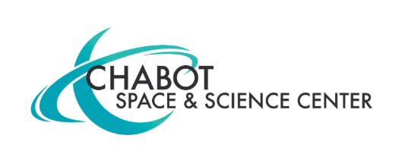
Contact:
Mary Catherine Frantz
Chabot Space & Science Center
pr@chabotspace.org, 510-336-7338

NASA Lands in Oakland! New Partnership with Chabot Space & Science Center Will Create NASA Learning Opportunities in the East Bay

(OAKLAND, CA) April 15, 2021 — A new partnership between NASA’s Ames Research Center in California’s Silicon Valley and Chabot Space & Science Center in Oakland, California, is now underway. Anchoring the partnership, a new visitor center for Ames will provide an immersive, dynamic STEAM environment called “The NASA Experience," opening at Chabot in November 2021.

Under the terms of a 5-year Space Act Agreement, the organizations are beginning a long-term collaboration to create accessible STEAM (science, technology, engineering, art, and math) community engagement and education opportunities in Oakland and beyond.
“We are delighted to have this opportunity to bring a deeper NASA experience into our surrounding communities," said Eugene Tu, director of Ames. "It's one of NASA's founding functions to share our work as widely as possible, and this partnership for a new visitor’s center will allow us to reach more broadly than we'd ever be able to do with our existing resources and location in the South Bay."
Under the formal agreement, NASA and Chabot have identified three main areas for immediate collaboration that leverage the strengths of NASA’s research and Chabot’s long-standing programs.

First, The NASA Experience creates an immersive, dynamic, STEAM learning environment that puts the visitor into the role of a NASA researcher. Hands-on STEAM studios highlight the current science at NASA through interactive challenges, models, artifacts, and more. The visitor center brings to life the thrilling, challenging, and inspiring process of scientific discovery by showcasing the real stories and people at NASA’s Ames Research Center.

“We are so excited to share the fascinating science, extraordinary people and groundbreaking research of NASA’s Ames Research Center right here in Oakland," said Adam Tobin, Executive Director at Chabot Space & Science Center, "Bringing together NASA Ames' long legacy of innovation and Chabot's 137-year history in STEM education creates a powerful opportunity to inspire the next generation of future scientists, engineers and astronomers.”

Leading up to the November opening, Chabot and Ames will provide engaging virtual programs hosted on Chabot Space & Science Center’s Facebook and YouTube platforms to offer participants a closer look at NASA’s mission.

Second, the two groups will create an interconnected network of STEAM education experiences throughout the city that deepens Chabot’s existing “Learning Everywhere” initiative. Building on existing connections with Oakland’s schools, libraries, and local organizations, this partnership will create programs that engage learners in current NASA research.

Third, the partnership will create tangible STEAM career pathways by developing explicit connections between NASA’s career opportunities and Chabot’s youth development programs. NASA will provide speakers, fieldtrips, and independent study on the missions and technology associated with work happening at NASA Ames in collaboration with Chabot’s Galaxy Explorers program, first established in 2000.

Chabot Space & Science Center is a non-profit institution, community resource, and hub for interactive STEAM engagement in Oakland. Founded in 1883, Chabot’s mission is to inspire and educate learners of all ages about the universe and planet Earth.

NASA's Ames Research Center, one of 10 NASA field centers across the country, is located in the heart of California's Silicon Valley. Since 1939, Ames has led NASA in conducting world-class research and development in aeronautics, exploration technology, and science aligned with the center's core capabilities.

***

