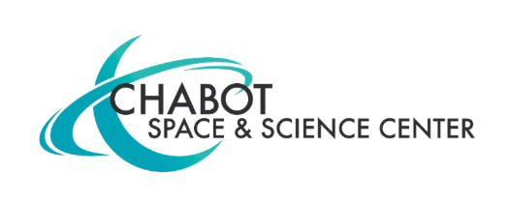
Contact:
Mary Catherine Frantz
Chabot Space & Science Center
pr@chabotspace.org, 510-336-7338

Chabot Space & Science Center Announces Sponsorship of Fremont Bank Studio 1

(OAKLAND, CA) July 13, 2021 — Chabot Space & Science Center (Chabot), has announced that Fremont Bank Foundation will sponsor a redeveloped 3,600-square-foot gallery, newly named Fremont Bank Studio 1. Fremont Bank Foundation’s $500,000 sponsorship will fuel Chabot’s transformational renovations and support accessible S.T.E.A.M. (science, technology, engineering, art and math) programming at the Center and throughout the community.
“Fremont Bank Foundation is a true advocate for students’ education, particularly around science, technology, engineering, the arts, and math,” said Brian Hughes, Fremont Bank executive vice president and Fremont Bank Foundation president and executive director. “Naming Studio 1 after Fremont Bank is a fitting tribute to the kid in all of us while we also celebrate Chabot’s Bay Area legacy and its exciting new visitor center -- The NASA Experience.”
Fremont Bank Studio 1 will be a focal point for The NASA Experience, opening at Chabot in November 2021. The new visitor center brings to life the thrilling, challenging and inspiring process of scientific discovery by showcasing the real stories and people at NASA’s Ames Research Center.
“Space travel is a big dream of so many youth. Even big kids, like us adults, continue to be fascinated by it. Visitors to Studio 1 will marvel at all the hands-on NASA experiences available, and, hopefully, carry that excitement with them into the future,” said Hughes.
About Chabot Space & Science Center
Founded as an observatory in 1883, today Chabot Space & Science Center offers visitors the very latest in hands-on, interactive exhibits, displays, and planetarium shows. Combined with a full program of activity-filled classes, workshops, community engagement programs, and special events, Chabot Space & Science Center is the Bay Area's go-to destination for visitors of all ages who want to discover and learn about science.
###

