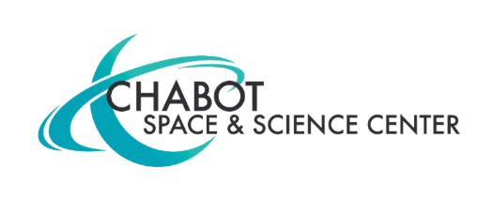
Contact:
Mary Catherine Frantz
Chabot Space & Science Center
pr@chabotspace.org, 510-336-7338

Chabot Space & Science Center to Reopen to the Public November 12 Featuring State-of-the-Art Renovations with a New NASA Ames Visitor Center
Chabot Will Debut to the Bay Area the Long-Anticipated, One-of-a-Kind Exhibition called The NASA Experience
(OAKLAND, CA) October 14, 2021 — Chabot Space & Science Center will reopen November 12 with a new NASA Ames Visitor Center, following more than 18 months of closure to complete construction on the largest Center-wide refresh since 2000. As part of a landmark partnership with NASA’s Ames Research Center, a new exhibition will debut at Chabot titled The NASA Experience. Visitors will come face-to-face with inspiring artifacts and hands-on learning opportunities that have never before been on display.

“We are thrilled to share with you all the new experiences Chabot has to offer,” said Executive Director, Adam Tobin, “Chabot is kicking off an exciting next chapter to re-envision science education in partnership with NASA’s Ames Research Center in Silicon Valley, making visible the extraordinary people and legacy of discovery at NASA. We look forward to welcoming back our community with new opportunities to experience wonder, joy and learning together.”

The NASA Experience will feature some of the most fascinating items in space research and exploration, including spacesuits from the Mercury and Gemini missions, experimental heat shield technology, and a fan blade from the world’s largest wind tunnel. Many of these items have never been on display to the public. This exhibition will bring to life the thrilling, challenging, and inspiring process of scientific discovery by showcasing the real stories and people at NASA’s Ames Research Center. Visitors step into the role of a NASA scientist by embarking on hands-on activities and connecting with real NASA scientists in interactive stations. Here, visitors will be able to design and build rovers, planes, and space robots for exploration, then test them in extraordinary environments inspired by labs at NASA’s Ames Research Center.
Press Images Available Here

Chabot Space & Science Center will mark reopening weekend with three days of festivities with extended hours to accommodate demand. Tickets will be limited, and visitors are encouraged to buy their timed tickets in advance. Reopening weekend will feature researchers and scientists from NASA’s Ames Research Center, including astronaut Dr. Yvonne Cagle. Additionally, the weekend will include performances and workshops with community partners, a space-themed collaborative build zone, robotics demonstrations by teen Galaxy Explorers and more.

Beginning November 20, Chabot’s regular hours will be Saturday and Sunday from 10 a.m. to 5 p.m. with extended holiday hours. Timed tickets through December 30 and current COVID-19 policies are now available online. Advanced tickets are highly encouraged for all visitors and members.

Visitors will enjoy a refreshed and welcoming museum experience with transformative renovations to the Center such as significant updates to the museum layout, courtyard, exhibitions and esthetics. Spectacular new murals from local artists Cece Carpio and Lindsey Millikan will also debut in Chabot’s Spees Building.

Chabot’s transformation is generously funded in part by The Gordon & Betty Moore Foundation.

ABOUT CHABOT SPACE & SCIENCE CENTER
Chabot Space & Science Center is a non-profit institution, community resource, and hub for interactive STEAM engagement in Oakland. Founded in 1883, Chabot’s mission is to inspire and educate learners of all ages about the Universe and planet Earth.
Chabot’s hours are 10 a.m.-5 p.m Saturday and Sunday. General admission is $24 Adult (12+), $19 Children and Seniors. Free for members and children 2 and under.
***

